**AWS Task-4**

**Task Description:**

Launch an EC2 instance (Linux and Windows) along with a web server. Then, create an EBS volume of 5 GB, attach it to an EC2 machine (Linux and Windows), and take a snapshot. Finally, create an EBS volume using the taken snapshot.

**Step 1 – Create EC2 Instance (Linux and windows)**

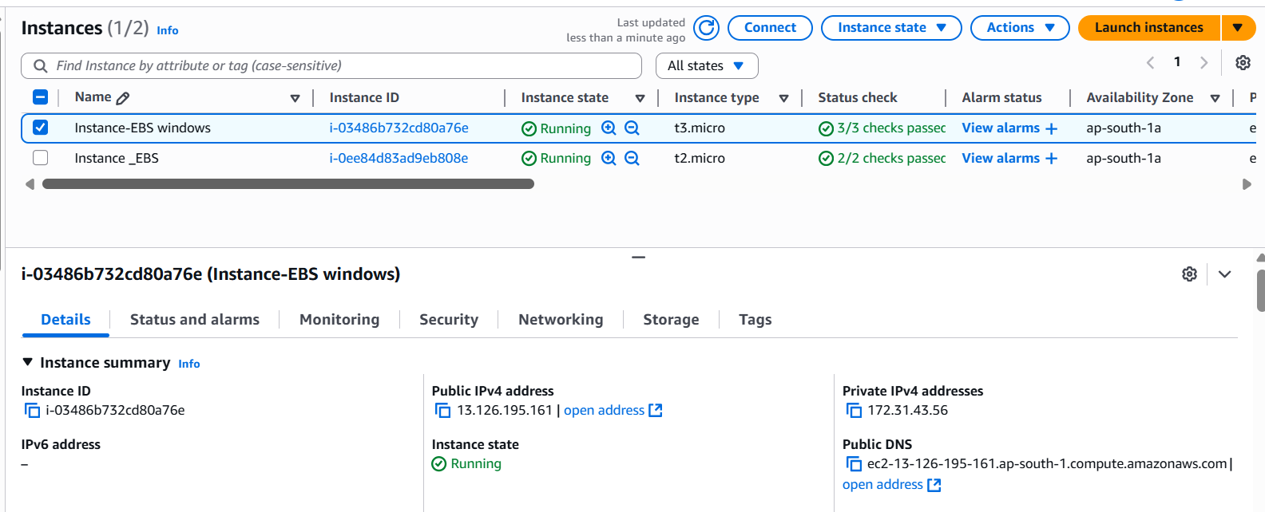

**Step 2 : Create EBS Volume –5GB and attached the volume and mount EBS (Linux)**

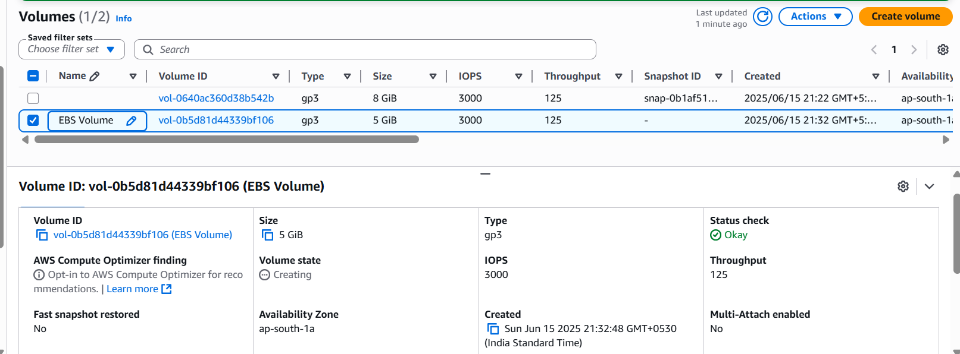

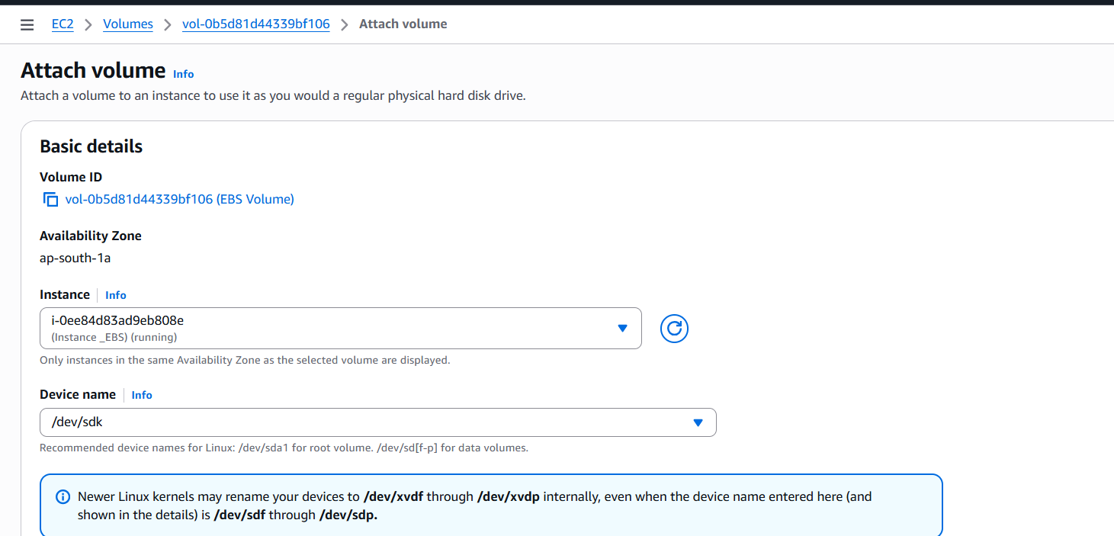

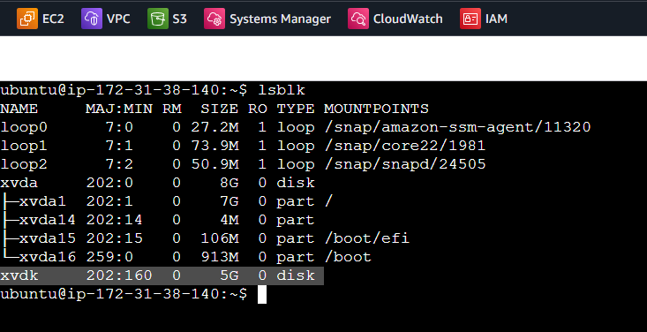

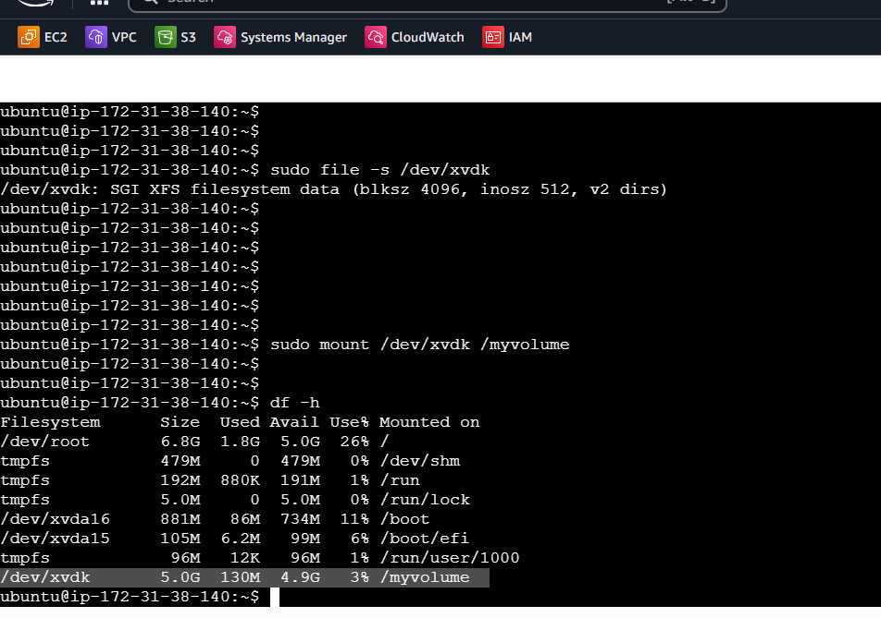

**Step 3 : Create EBS Volume –5GB and attached the volume and mount EBS (Windows)**

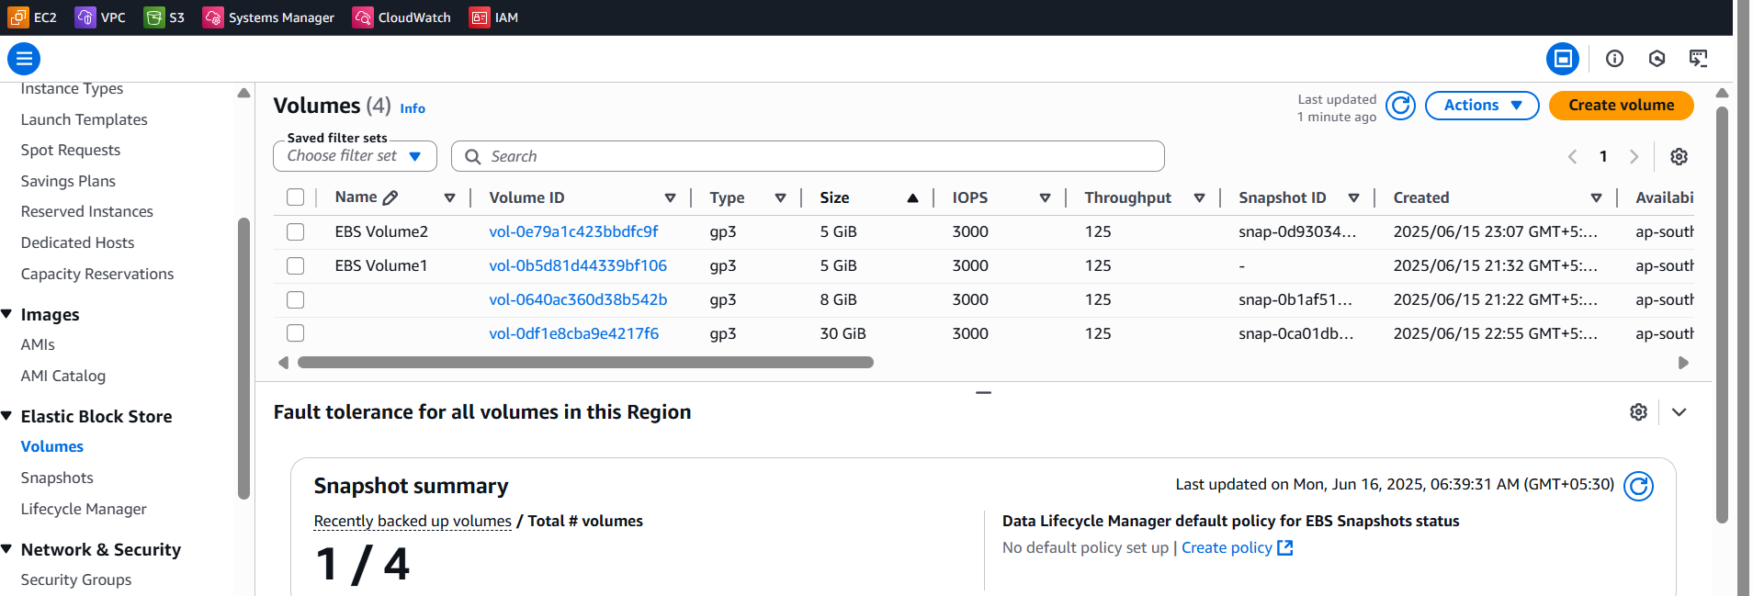

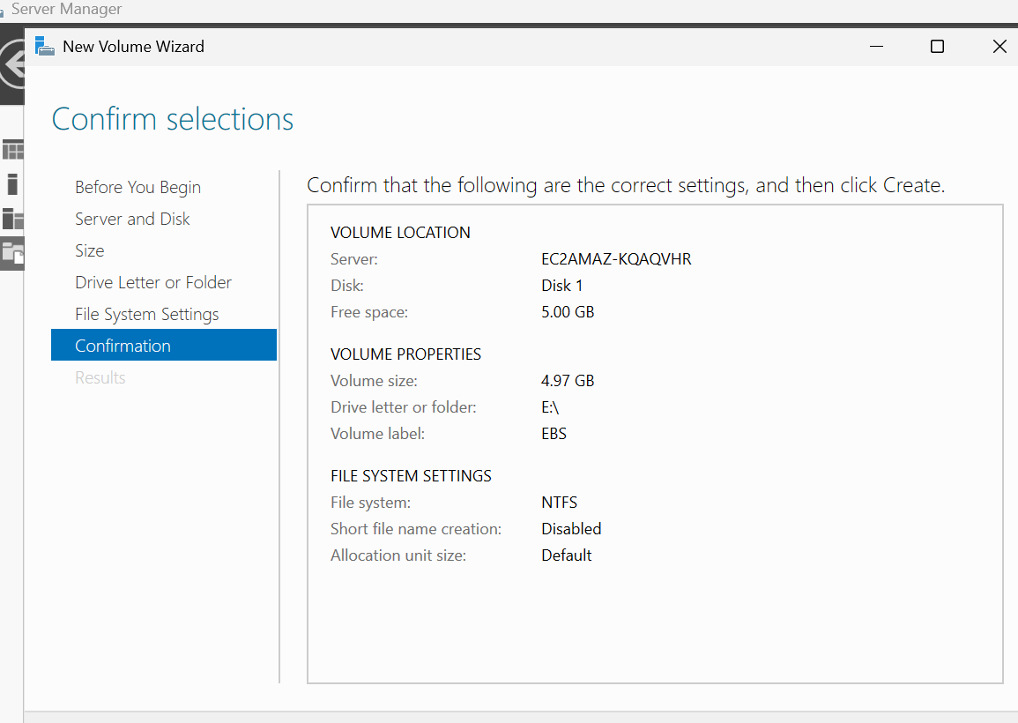

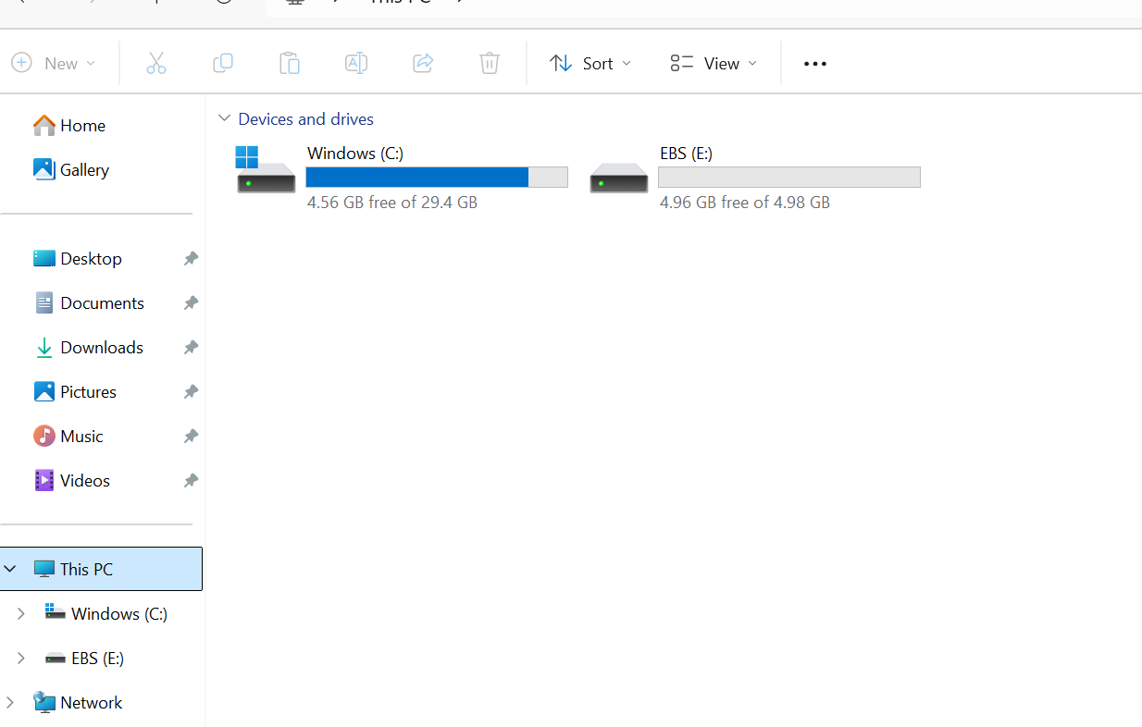Step 4: Snapshot has

**Step5 :Created an EBS volume using the taken snapshot**  
